
Submitted to Ma’am Mahnoor

PROJECT: Library
Management
System

A
GROUP
PROJECT BY
BSCS
-
02

GROUP MEMBERS:

Hamza Rashid

Afaq Hasan

Fahad Safeer

M Hasnat

Library Management System

REPORT

Introduction:

The Library Management System developed in C++ is designed to optimize, refine the basic operations of a library. Storing records manually in a library can be inefficient and prone to errors when tracking books that are currently available, borrowed or need to be returned. This project solves all those issues by developing a simple yet efficient management system.
Project Description:
The project is basically a practical application of Object Oriented Programming. A main class Library is the center of this system containing all the access specifiers and member functions that are used.
The system uses Encapsulation to protect the data, by storing the Book IDs, Titles, and Availability in private arrays. This private data is accessed via three main public methods: displayBooks() to view information about books such as; name, title and availability, borrowBook() to borrow the book from library, and returnBook() to return items to the library.

Code Walkthrough(System implementation & Code Analysis)

1. Class and Encapsulation
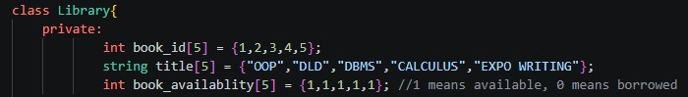
The code uses a class named Library in which private access specifier is used to restrict access to data such as availability of book, their ID’s and title. It ensures that there is no direct access from main() to prevent accidental overwriting or corruption of code. This makes this private data only accessible by the functions with in the Library class.

2. displayBooks() Member Function
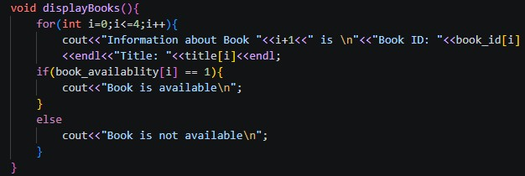

A displayBooks() function is written in public specifier of the class that is used to display information regarding books in the Library. This information consists of name, Book ID, Title and availability. A for loop is used to make sure that information of all books is displayed and a if-else statement is used to check the availability of the book.

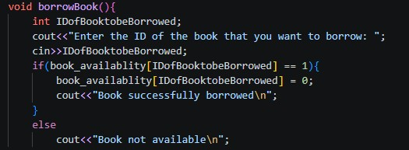
3.

borrowBo
ok() Member Function

A borrowBook() function is used to borrow a book from the library. It asks the user to enter the ID of the book that he/she wants to borrow, then uses an if-else statement to check whether the book is available or not and then displays the result accordingly.

4. returnBook() Member Function
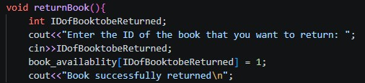
A returnBook() function is used to return the borrowed books. It uses the ID of the book for returning and makes sure to change the availability of the book in the private access specifier Book_ID.

5. Main() code for the initial menu & user choice
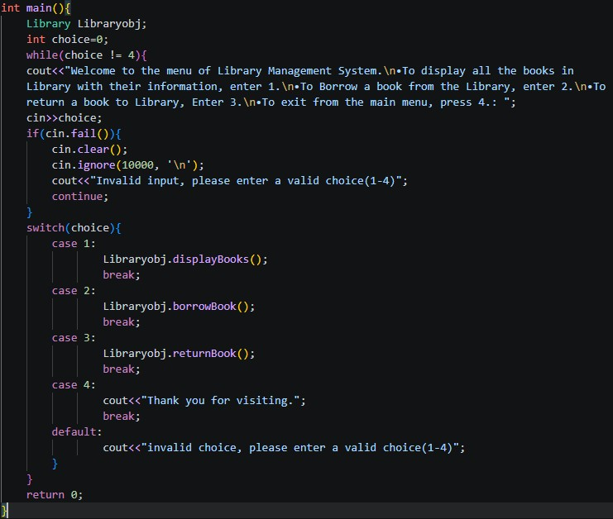

Inside the main(), we have a while loop wrapped around the code to display a menu that keeps on showing unless the user wants to quit the menu. The code consists of different choices and asks user to enter the number of what operation he/she wants to perform. After that a switch statement is used to perform an action according to what user wants to do.

6. Output/Terminal view of the code
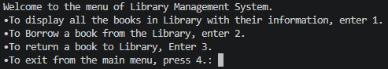

A welcome message at the start of the code and all the different options user can explore with their different assigned numbers to perform those actions.
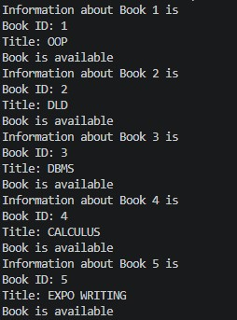
Upon entering 1, the code executes the switch statement and runs the case with 1 assigned to it. This runs the displayBooks() function in the class displaying information regarding all the books in the library.
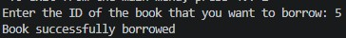
Upon entering 2, the code executes the case 2 of switch statement running the borrowBook() function of the class. It checks whether the book is available or not and then either lends the book or tells the user that book is not available.
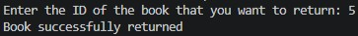
Upon entering 3, the code executes the case 3 of switch statement running the returnBook() function of the class. It asks the user the ID of the book that is to be returned and makes sure to change the availability so that the book can be borrowed in the future.
Upon entering 4, the condition of while loop results in true meaning that after the case 4 of switch is ran, the code will no longer repeat and show the menu, officially quitting the menu of the system.

Issues resolved
- Eliminated Human Error by replacing manual inputs and storing to automated and added real-time tracking.
- Minimized the delay time by adding loops to check for inventory, availability.
- Ensures data integrity by encapsulating important data.

Conclusion
In conclusion, this Library Management System is an implementation of OOP in C++ using the concepts of Classes, Encapsulation and control structures to tackle all the issues that are faced by a library management system that records everything manually. This management system ensures to remove all the human error, remove delay time and ensure data integrity while also performing all the basic functionalities of a library.

